# [**TV Fan Favorites 2020: 'Law & Order: SVU' Crimefighter Olivia Benson**](https://www.tvinsider.com/942598/olivia-benson-svu-fan-favorite-tv-crimefighter/)

[***Ileane Rudolph***](https://www.tvinsider.com/author/ileane-rudolph/)JULY 30, 11:00 AM

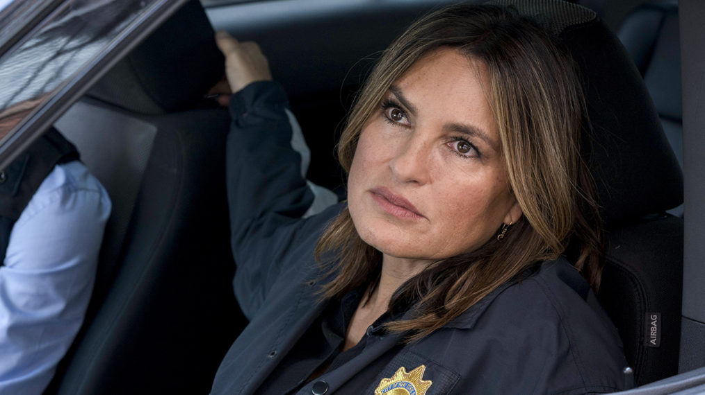

Virginia Sherwood/NBC

***Here we go, TV fans. Welcome to our re-booted, re-vamped and reinvigorated*** [***Fan Favorite Poll results!***](https://www.tvinsider.com/category/fan-favorites/) ***You spoke and we listened, so stay tuned as we roll out the winners over the coming days!***

Not long after [**Mariska Hargitay**](https://www.tvinsider.com/people/mariska-hargitay/) began portraying sex crimes investigator Olivia Benson on [***Law & Order: SVU***](https://www.tvinsider.com/show/law-order-svu/) 21 years ago, she realized how much the tough and compassionate NYPD officer had struck a chord with many who watched.

"I was quickly educated about how this show was affecting people," the [**Emmy**](https://www.tvinsider.com/show/emmys/) and [**Golden Globe**](https://www.tvinsider.com/show/golden-globe-awards/) winner told TV Guide Magazine in 2018. The tone of the fan mail and the encounters she had with viewers were unlike anything she'd experienced. "People would say, 'Thank you…I've never told anyone before [about my sexual abuse],'" continued Hargitay. "It's always been a personal connection."

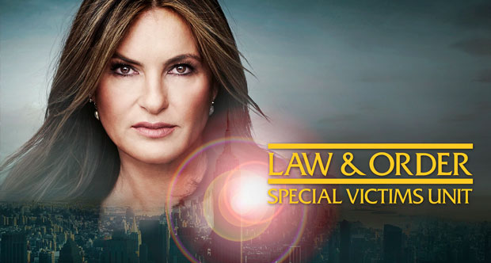

#### **DON'T MISS A THING!**

###### Get **absolutely everything** about **Law & Order: SVU** in your inbox!

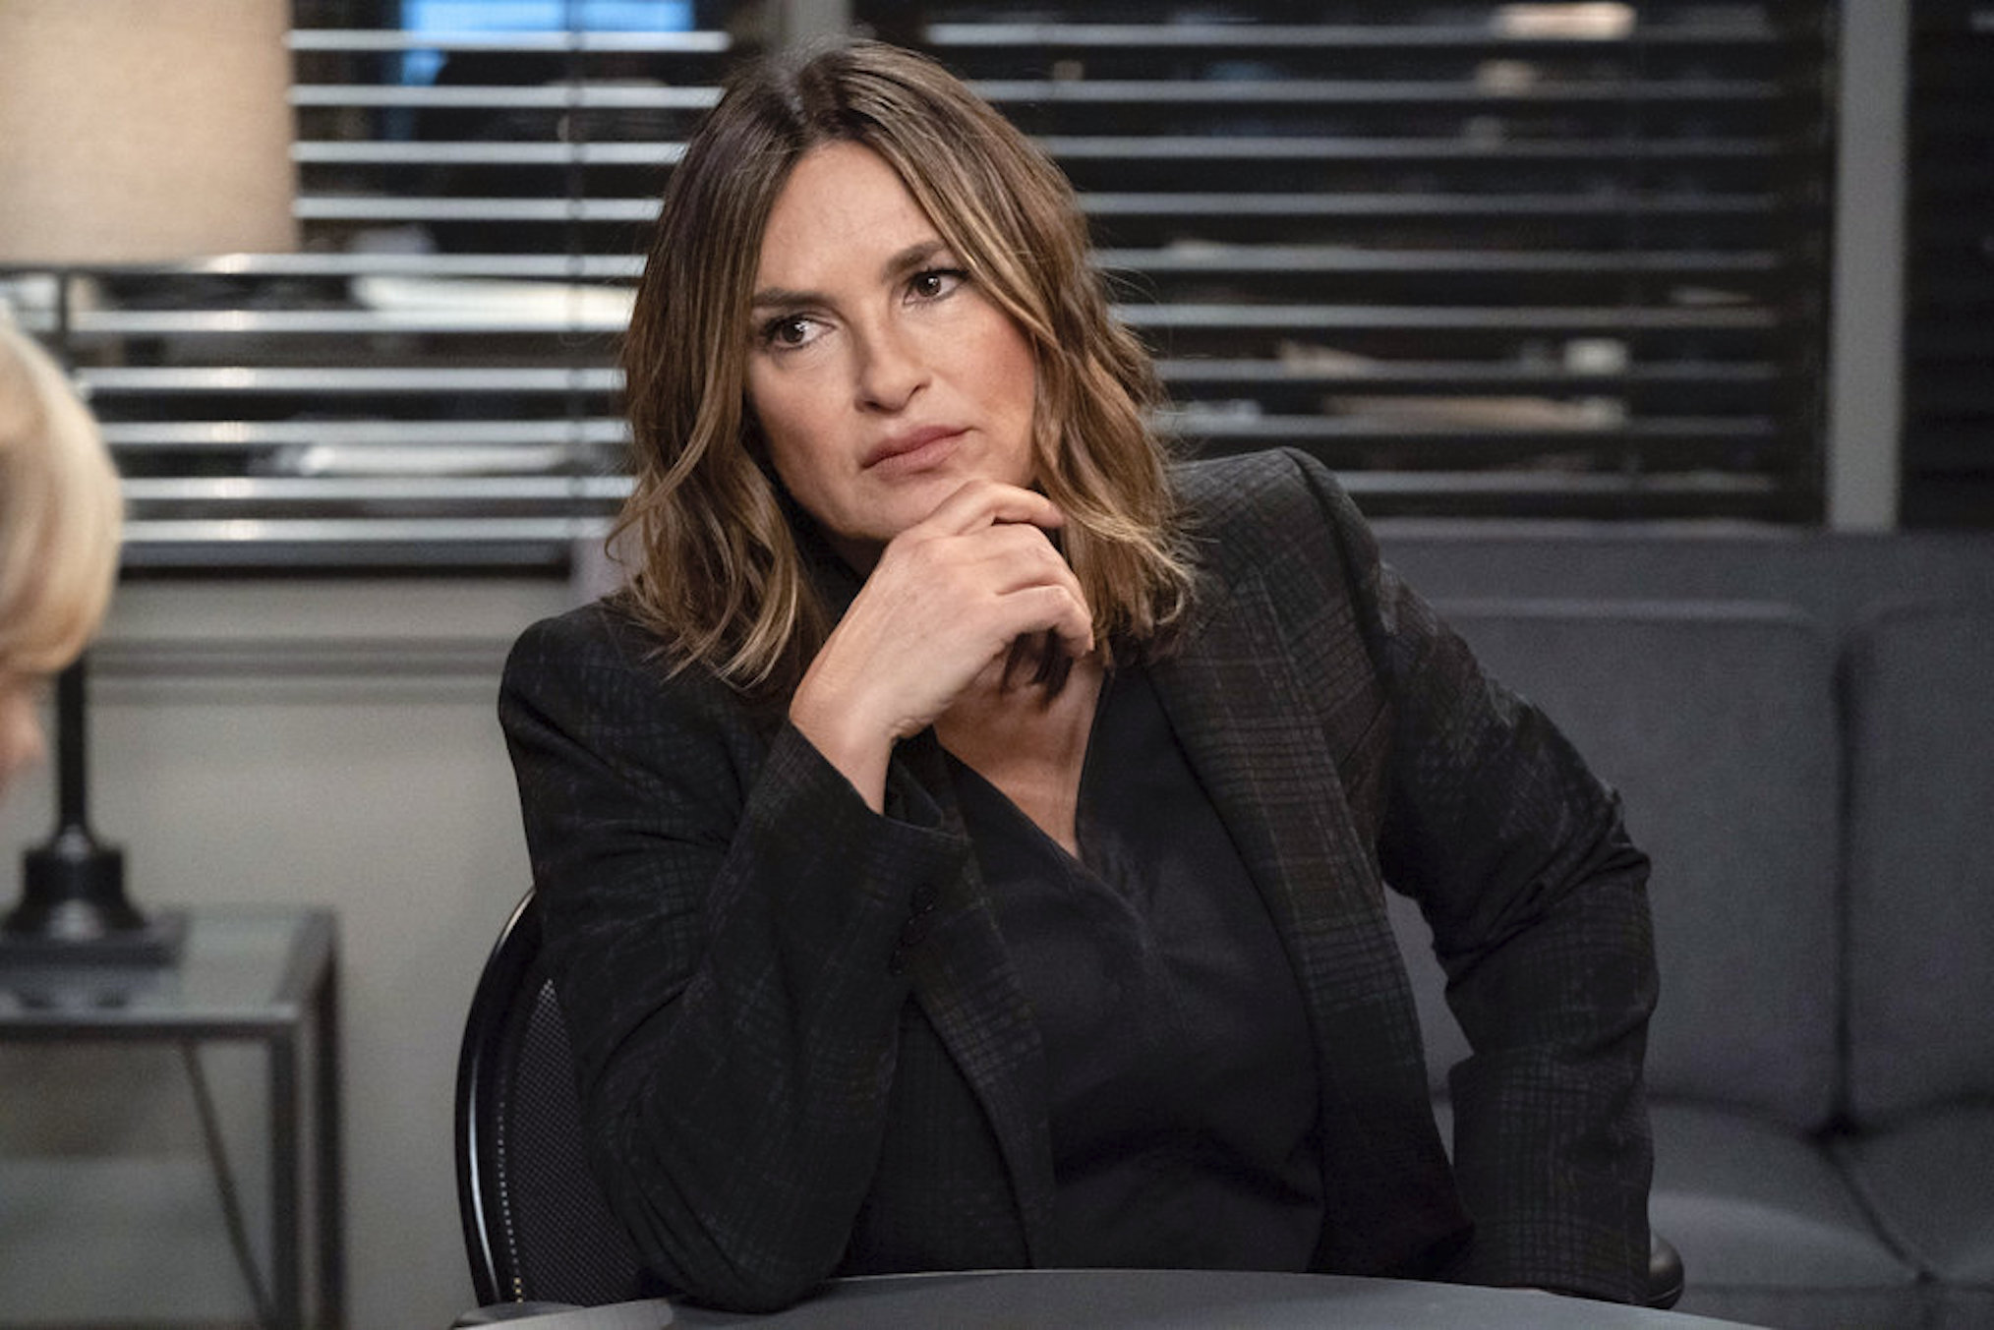

(Virginia Sherwood/NBC)

It's one that goes beyond what we see on TV: Through her Joyful Heart Foundation, Hargitay has raised millions of dollars to end the national backlog of untested rape kits. A hero on- *and* offscreen!

### [***Check out more of our Fan Favorite Poll winners over here!***](https://www.tvinsider.com/category/fan-favorites/)

***Law & Order: SVU*, Season 22, Fall 2020, NBC; stream Seasons 1–21 on Hulu and select episodes on nbc.com**